Electric Vehicles in the U.S.

Question

How are Electric Vehicles impacting the automobile industry? The comparison between competitors? Growth vs Decline vs Consistency.

Findings:

Using data from 2011 to 2016, I was able to visualize this dataset by showing trend in sales over the years by the brand. I wanted to focus solely on EVS instead of HEVS. There has been an overall growth of sales in the market since 2011. Tesla, BMW and Nissan seem to be the top players in EV market and have growth yearly. Nissan has shown the most consistency in EV sales since earlier debut in 2011. Tesla has shown tremendous growth nearly 20x during a 5-year span.

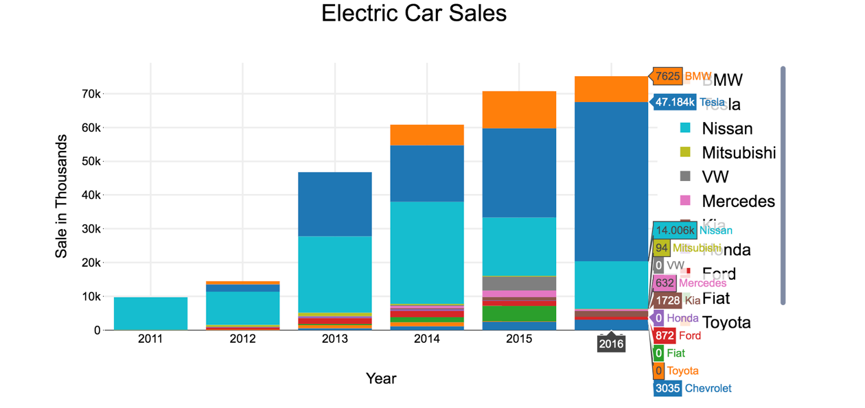

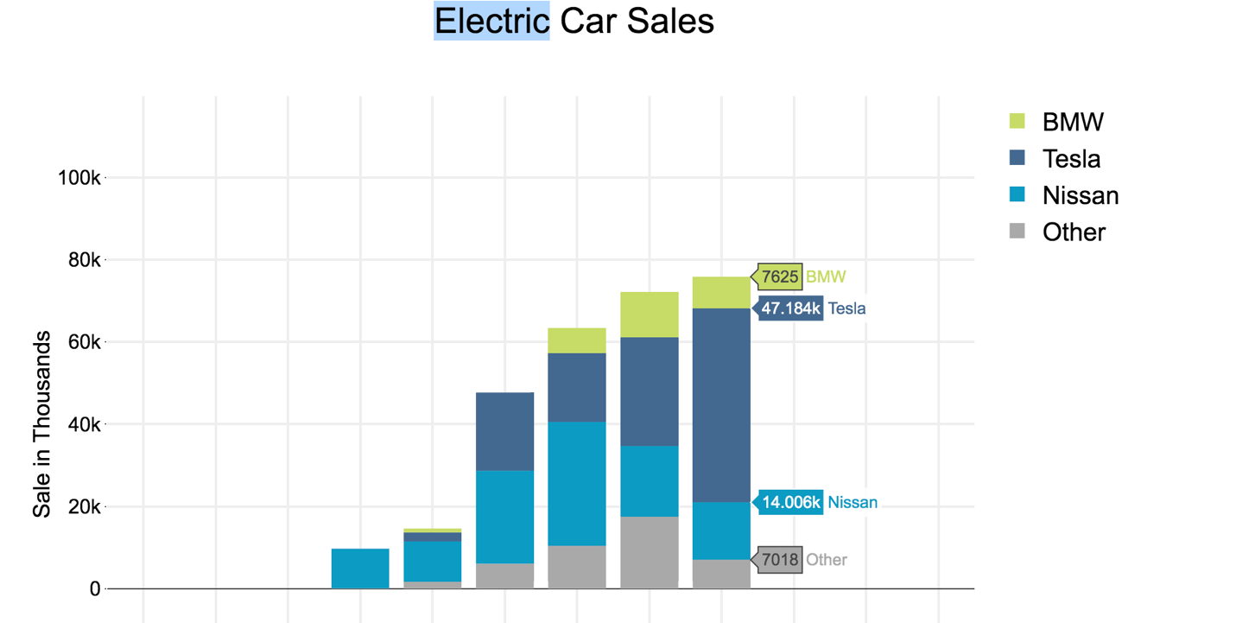

As shown above, BMW, TESLA AND NISSAN amongst their competitors

Sources:

1. [Kaggle](https://www.kaggle.com/CooperUnion/cardataset) Contains information about cars used in United States from 1990 to 2017.It includes information like Engine type, Miles per Gallon, Popularity, MSRP for each Model. Data was originally obtained from
2. [afdc.gov](https://www.afdc.energy.gov/data/) Contains information about sales of electric cars in United States from 2011 to 2016 for different brands and models.